Cognitive Insight Audit Framework Lazy Capsule Materialization (CIAF-LCM) with Governance Gates:
Lifecycle Evidence and Runtime Enforcement for AI Systems
Denzil Greenwood
Founder and Head Researcher, CognitiveInsight.ai
Draft position and architecture paper
April 2026

Purpose | Explain the operating model of lifecycle receipts, lightweight runtime capture, triggered evidence materialization, and governance-as-enforcement.
Central claim | AI governance becomes actionable when the lifecycle is modeled as a sequence of evidence-bearing events and control points rather than as a set of static policies and documents.
Paper role | This paper operationalizes the category paper by defining receipts, lazy capsule materialization, and governance gates as the core mechanics of lifecycle accountability.

Abstract
This paper presents CIAF-LCM with Governance Gates as an operating model for AI lifecycle accountability. The core argument is that governance becomes operational only when consequential lifecycle transitions and runtime actions are expressed as evidence-bearing events, each capable of producing independently verifiable receipts. CIAF-LCM, or Lazy Capsule Materialization, addresses a practical tension in AI governance: strong accountability typically requires rich evidence, while production systems require low runtime burden. The proposed model resolves this tension by capturing lightweight evidence footprints continuously and materializing heavier evidence capsules only when triggered by a policy gate, an audit demand, a runtime escalation, an incident, or another inspection event. The paper defines the receipt model, explains the gate taxonomy, describes deny-by-default enforcement and denial receipts, and walks through an end-to-end lifecycle example from dataset registration through training, validation, deployment, runtime inference, and investigation. It positions CIAF-LCM as a model-agnostic lifecycle mechanism inside the broader category of AI Governance Evidence Infrastructure and argues that the combination of lifecycle receipts and governance gates provides a practical path from policy theater to proof-bearing control.
1. Introduction
The category paper argued that high-stakes AI needs an evidence layer capable of proving what happened, why it happened, under what authority it happened, and whether required controls were enforced. This paper narrows the focus from the category level to the operating model. Its subject is CIAF-LCM with Governance Gates: the mechanism by which lifecycle events become verifiable receipts and by which governance is expressed as runtime-capable enforcement rather than static aspiration.
The design problem is straightforward but stubborn. Rich evidence capture can create cost, performance, privacy, and storage pressures, especially in systems with high interaction volumes or large numbers of intermediate artifacts. Yet weak capture leaves organizations with gaps that are often discovered only during an audit, incident, or legal dispute. Existing standards and governance frameworks reinforce the need for lifecycle traceability and durable control evidence, but they do not prescribe a concrete operating model for how to obtain it. The NIST AI RMF treats governance as a cross-cutting function across the AI lifecycle, while the EU AI Act places explicit emphasis on automatic logging and record-keeping for high-risk systems.[1][2] CIAF-LCM is proposed as a design pattern for making that expectation implementable.
The central claim of this paper is that AI governance becomes actionable when the lifecycle is modeled as a sequence of evidence-bearing events and control points. In this view, datasets, training runs, evaluations, promotions, deployments, runtime decisions, tool invocations, escalations, denials, and incidents are not merely operational facts; they are potential evidence objects. Governance gates convert policy requirements into explicit state transitions, while lazy capsule materialization manages the cost of evidence collection by separating continuous lightweight capture from triggered heavy materialization.

Figure 1 Receipt anatomy and lifecycle placement
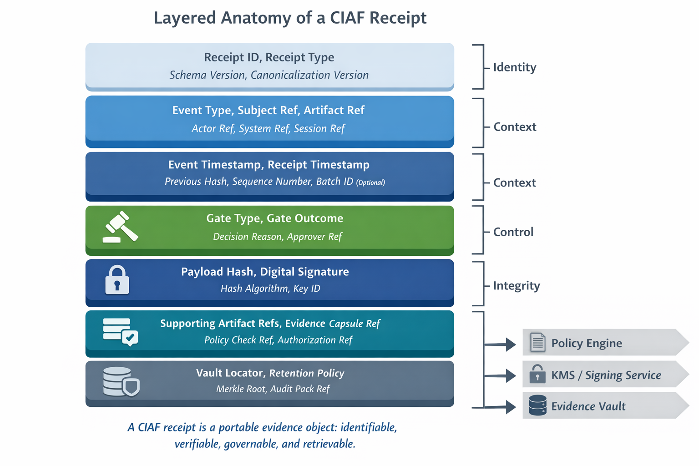
Figure 1. Receipt anatomy and lifecycle placement: a layered anatomy of a receipt showing identifiers, cryptographic bindings, references, timestamps, signatures, gate outcome, and retrieval pointers.
2. Design Goals
CIAF-LCM is governed by five primary design constraints.
- First, the runtime burden must remain low enough that evidence capture does not become operationally prohibitive.
- Second, the resulting evidence must be independently verifiable rather than dependent on trust in the platform that generated it.
- Third, receipts must be portable so they can be exchanged across organizational, vendor, and audit boundaries.
- Fourth, the lifecycle model must remain model-agnostic so it can describe classical machine learning, deterministic decision systems, large language models, retrieval-augmented systems, and agentic workflows without collapsing into one vendor-specific event grammar.
- Fifth, the system must remain inspection-ready, meaning that evidence can be retrieved, reconstructed, and explained after the fact without relying on fragile narrative reconstruction.
These goals intentionally distinguish CIAF-LCM from ordinary telemetry collection. Observability stacks such as OpenTelemetry are optimized to generate, export, and collect traces, metrics, and logs so operators can understand system state and behavior.[3] CIAF-LCM does not replace observability; it overlays governance semantics and evidence structure on top of lifecycle events that matter for accountability. Where observability seeks system understanding, CIAF-LCM seeks verifiable accountability.
The design also assumes that evidence is not binary. Information about the AI lifecycle event is collected, utilized for gate operations and retained for historical data.
The architecture therefore optimizes for maximal capture everywhere, and for accountable selectivity disclosure for just-in-time compliance, regulatory review or incident review and remediation.
3. Lifecycle Events and Receipt Structure
A lifecycle receipt is the atomic accountability object in CIAF-LCM. It is not a screenshot, a dashboard row, or an unstructured log line. It is a structured record designed to stand on its own as an evidence-bearing object while also linking to prior and downstream events. At minimum, a receipt should include a globally unique receipt identifier; a receipt type; a canonicalization version; a timestamp and time source; references to the subject event, artifact, or decision; cryptographic hashes over the canonicalized evidence payload; signature metadata; a key identifier; and the policy or control context under which the receipt was created.
Required receipt elements should be small enough to capture continuously. These typically include the event class, subject references, principal or actor reference, model or system identifier, policy context identifier, minimal outcome fields, and cryptographic bindings. Optional receipt elements may include human-readable explanations, supporting artifacts, evaluation pointers, feature lineage pointers, prompt or retrieval hashes, environment details, approval chains, justification text, and retrieval links into the evidence vault. The distinction between required and optional fields is essential to the LCM pattern: all receipts must be verifiable, but not all receipts must be equally heavy.
The structure should also support linkage. A training receipt should reference the dataset receipt or dataset root used for training. A validation receipt should reference the specific training receipt and evaluation bundle. A deployment receipt should reference the validated model state and the promotion gate outcome. A runtime action receipt should reference the deployed state, the acting principal or agent, and the policy decision that allowed, denied, or escalated the action. In this way, receipts form a chain of evidence rather than a flat event ledger.

Table 1. Minimal receipt field model
Field | Status | Purpose | Example content
receipt_id | Required | Unique evidence object identifier | rcpt:deploy:2026-04-18:0012
receipt_type | Required | Event class for interpretation | deployment_receipt
canonicalization_version | Required | Normalizes payload before hashing | ciaf-c14n-1
subject_ref | Required | Artifact, decision, or action being evidenced | model:v4.3.2
actor_ref | Required | Human, service, or agent principal | agent-claims-001
policy_context | Required | Policy or control regime in force | approval-gate-v2
hash / signature | Required | Integrity and non-repudiation binding | sha256 + Ed25519
supporting_refs | Optional | Links to artifacts, approvals, evals, prompts | eval_bundle:2026q2-a

4. Lazy Capsule Materialization
Lazy Capsule Materialization is the rule that separates continuous capture from full evidence expansion. Under this approach, the system records small, durable footprints at event time and postpones expensive enrichment until a trigger justifies it. A footprint might include the event identifier, event type, actor reference, subject reference, timestamp, policy context, and cryptographic bindings. A fully materialized capsule may additionally include evaluation artifacts, approval records, environment attestations, feature lineage, prompts or context digests, attached explanations, related tickets, denial rationale, and retrieval pointers for supporting objects.
This separation matters for performance and storage. Runtime-heavy systems can generate millions of events whose accountability value is highly uneven. Capturing every associated artifact at full fidelity would quickly create cost and privacy burdens, and in some environments it could also increase operational risk by over-retaining sensitive inputs or outputs. By contrast, a lightweight footprint preserves the existence, integrity, ordering, and minimum interpretability of the event while leaving deeper materialization to moments when inspection value exceeds collection cost.
Materialization triggers should be explicit. Common triggers include entry to a governance gate, model promotion, approval or denial of a privileged action, policy conflict, threshold breach, human override, incident declaration, dispute initiation, regulator or auditor request, random control sampling, or export of an artifact into an external environment. The key architectural principle is that materialization is not arbitrary; it is control-linked. This gives the system a principled answer to the question of why a heavy evidence object exists for one event but not another.
Figure Placeholder 2
Lifecycle timeline with light capture and trigger points

Figure 2. Suggested figure: a timeline from dataset registration through runtime action, highlighting which events create lightweight footprints and which ones trigger full materialization.
5. Governance Gates
Governance gates are the enforcement points that translate policy into lifecycle state transitions. They are not merely review checkpoints. A gate evaluates whether prerequisites have been satisfied and produces an explicit outcome: approve, deny, escalate, or inspect. In a deny-by-default architecture, the burden is on the system to prove that required conditions were met before a consequential event or action was allowed to proceed. The gate therefore functions as both a control mechanism and an evidence generator.
Several gate types are especially useful. A provenance gate checks whether a dataset, artifact, or external dependency satisfies source, lineage, or handling requirements. A validation gate checks whether evaluation prerequisites, thresholds, and review criteria have been met before a model can advance. An approval gate checks whether the required human or system authorization has been granted. A deployment gate checks whether the release artifact corresponds to the approved and validated state. A runtime gate mediates sensitive inferences, tool use, or agent actions. An incident gate governs transitions into containment, investigation, or remediation flows. Additional sector-specific gates can be layered on top of these core types.
Denial receipts are a core feature, not a side effect. When a gate blocks an action, the system should emit a signed denial receipt that records the attempted action, acting principal, evaluated rule or policy bundle, decision outcome, time, and denial reason. This matters because successful governance is often expressed in actions that did not occur. Without denial receipts, organizations can claim that a policy exists but have limited evidence that the policy actively constrained the system in practice.
Table 2. Gate taxonomy
Gate type | Purpose | Typical trigger | Control effect
Provenance | Verify source, lineage, and handling constraints | Dataset onboarding; import | allow / deny / inspect
Validation | Verify testing, thresholds, and review completeness | Model promotion request | approve / deny / escalate
Approval | Verify required authority and segregation of duties | Deployment or high-risk release | approve / deny
Runtime | Mediate sensitive decisions, tool use, and agent actions | Privileged action or policy-sensitive inference | allow / deny / escalate
Incident | Control containment and investigation state changes | Detected anomaly, complaint, or breach | inspect / contain / escalate

Figure Placeholder 3
State-machine outcomes for gate decisions

Figure 3. Suggested figure: a state-machine diagram showing approve, deny, escalate, and inspect paths, each emitting a corresponding receipt.
6. End-to-End Flow
Consider a high-stakes AI workflow in which a model is trained for claims triage and later used by a controlled agent to recommend or auto-execute downstream actions. The lifecycle begins with dataset registration. A dataset receipt is created containing the dataset identifier, source class, handling status, cryptographic root, and provenance gate outcome. The actual dataset contents need not be stored inside the receipt; the receipt binds the dataset state and relevant policy context.
A training run then produces a training receipt. The receipt references the dataset root, code version, environment digest, training parameters, and output model identifier. If the training run is ordinary and internal, the receipt may remain relatively light. If the run is selected for review or promotion, the system materializes a fuller capsule that includes environment attestation, reproducibility metadata, and supporting artifacts. A validation receipt follows, linking the candidate model to the evaluation bundle, thresholds, review outcomes, and validation gate result. Only after the validation and approval gates succeed can a deployment receipt be issued, binding the deployed artifact to the validated state and the approving authority.
At runtime, an inference receipt references the deployed model state and records the governance-relevant context of the interaction. If the system is agentic, a pre-action runtime gate evaluates whether the requested tool use or transaction is within authority. If the action is permitted, an action receipt records the decision path; if it is denied, a denial receipt is emitted instead. Later, if a complaint or anomaly triggers an investigation, the incident process materializes a linked bundle from prior receipts and supporting artifacts. The investigator is not forced to reconstruct the lifecycle from scratch because the evidence chain already exists.
7. Operational Tradeoffs
The LCM model improves accountability efficiency, but it does not eliminate tradeoffs. Performance costs remain, especially when gate evaluation requires complex policy checks or when materialization pulls large supporting artifacts into scope. Storage costs are lower than in always-capture systems, yet they are still meaningful because evidence must remain durable and queryable. Privacy constraints may also limit which prompts, inputs, outputs, or feature details can be retained directly. In many cases, hashes, references, and selective redaction will be preferable to wholesale payload retention.
Human workflow implications are equally important. Gates are powerful, but if they are designed poorly they can create friction, override fatigue, or a false sense of completeness. Governance design therefore needs calibration: not every event should face the same gate burden, and not every gate should require direct human intervention. Escalation logic, sampling strategies, and clearly defined control ownership help preserve operational usability.
Interoperability is another tradeoff. The value of a receipt architecture increases when receipts can move across tools, teams, and trust boundaries. However, portability is difficult when schemas are tightly coupled to a single platform or sector. CIAF-LCM therefore benefits from a thin required core, layered extensions, and stable canonicalization rules. This is also where the evidence vault becomes crucial: the vault paper will address custody, verification, and export mechanics in more depth.
8. Limitations and Future Work
This paper leaves several issues open. It does not propose a formal industry standard for lifecycle receipts, nor does it claim that one receipt schema will fit every regulated context. Sector-specific extensions will almost certainly be required for domains such as credit, healthcare, defense, or public-sector decision systems. The paper also does not resolve all questions around confidential computing, privacy-preserving evidence, selective disclosure, or zero-knowledge proof patterns for AI governance.
Another open issue is proof gradation. Receipts can differ in evidentiary strength depending on the quality of key management, the trust assumptions of the signing system, the durability of storage, and the completeness of linked artifacts. Future work should define assurance profiles so that consumers of the evidence can understand not just that a receipt exists, but what level of trust it meaningfully supports.
Finally, CIAF-LCM should be tested against real operational baselines. Future work should compare full-capture logging, lightweight receipt capture, and LCM-triggered materialization across throughput, storage growth, retrieval time, privacy exposure, and audit usefulness. Those comparisons will make the runtime and storage benefit of the approach empirically clearer.
9. Conclusion
CIAF-LCM with Governance Gates is the operational mechanism inside the broader category of AI Governance Evidence Infrastructure. Its premise is that governance becomes credible when lifecycle events and runtime actions are expressed as evidence-bearing state transitions rather than treated as documentation afterthoughts. Receipts provide the atomic units of accountability; lazy capsule materialization makes their collection operationally feasible; and governance gates make policy enforceable through explicit allow, deny, escalate, and inspect outcomes.
Taken together, these elements provide a model-agnostic approach to lifecycle accountability for high-stakes AI. The category paper defines why an evidence layer is needed; this paper explains how lifecycle evidence can be captured and enforced in practice. The next paper, focused on the evidence vault, completes the picture by specifying how these receipts and capsules are sealed, stored, linked, exported, and independently verified over time.
References
[1] NIST, "Artificial Intelligence Risk Management Framework (AI RMF 1.0)," 2023.
[2] EU AI Act Service Desk, "Article 12: Record-keeping," describing logging and traceability obligations for high-risk AI systems.
[3] OpenTelemetry Documentation, "What is OpenTelemetry?" and related logs and traces documentation.

AI uses disclosure:

This document, "AI Governance Evidence Infrastructure: A Category Framework for Cryptographically Verifiable AI Lifecycle Accountability," was prepared for concept development and publication planning, dated April 18, 2026. It was authored by Denzil Greenwood, Founder and Head Researcher at CognitiveInsight.ai.
In the creation of this document, AI tools were utilized to generate both the text and the supporting images, with human oversight applied to both processes.

Research Papers and Continued Work: AI Governance Evidence Infrastructure
- CIAF-LCM with Governance Gates: Lifecycle Evidence and Runtime Enforcement for AI Systems
- Tamper-Evident Evidence Vault for AI Lifecycle Events, Decisions, and Audit Packs
- Dual-Layer Provenance for AI-Generated Artifacts: Explicit Watermarks and Forensic Fingerprints as Evidence Infrastructure
- Governance Planes for Agentic AI: Identity, Policy, Privilege, Execution, and Evidence
- Shadow AI Governance: Bringing Unmanaged AI Use into the Evidence Perimeter
- CIAF-LCM Proposed Schema Documentation: Current Schema State, Architecture Fit, and Proposed Documentation Model

